Mini project report

On

**Sales insights of superstore**

Submitted By

Sidharth Nambiar (23MSM40036)

Kushagra Sharma (23MSM40047)

## Submitted To : Professor Gagninder Kaur



DEPARTMENT OF MATHEMATICS (M.SC DATA SCIENCE)

UNIVERSITY INSTITUTE OF SCIENCE

CHANDIGARH UNIVERSITY

APRIL 2024

# AKNOWLEDGMENT

We wish to express our profound gratitude to Professor Gagninder Kaur for her exceptional guidance and steadfast support throughout the duration of this project. Professor Kaur's profound expertise, astute insights, and unwavering commitment have been indispensable in shaping our understanding and execution of customer analysis. Her mentorship has not only enriched our learning journey but has also significantly contributed to the success of this endeavor.

We are deeply grateful for Professor Kaur's dedication to fostering our academic and professional growth, and we acknowledge her profound impact on our development as aspiring analysts. It has been an honour and privilege to benefit from her mentorship and expertise, and we extend our heartfelt appreciation for her invaluable contributions to this project.

# Summary of the Project

This Superstore Sales Analysis mini project was undertaken to extract actionable insights from a simulated dataset, with the objective of informing strategic decisions related to sales of different states in US country. Leveraging Tableau's visualization capabilities, the project aimed to dissect year wise data of company’s profits, top customers by sales value, top 10 cities sorted by profit and sales, top products of the company and product orders and returns.

# Introduction

This report outlines the methodologies, findings, conclusions, and recommendations resulting from the Superstore Sales Analysis Mini Project. The project sought to leverage data-driven approaches to enhance understanding of sales and profit of products and different cities.

# Methodology

1. Data Preparation: Rigorous data cleaning and preprocessing were conducted to ensure the integrity and consistency of the dataset for accurate analysis.
2. Visualization Creation: Utilizing Tableau, a suite of visualizations was crafted to explore and dissect various facets of the dataset, focusing on pertinent metrics for sales analysis.

# Findings

## TOTAL PROFIT

Using superstore sales dataset, we represent total profit of the company year wise which will help in getting the profit insights of company.

The insights of this graph is that in the year 2017 the company has witnessed maximum profit of $93.44K.

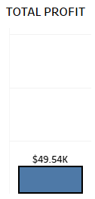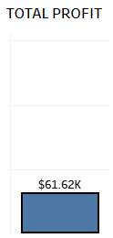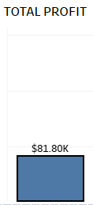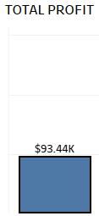

**TOP 10 CUSTOMERS**

Using superstore sales data set, we represent top 10 customers of this company sorted according to the sales value they bring.

The insights of this graph is that customer Seth venom has brought the highest sales of $11.47K.

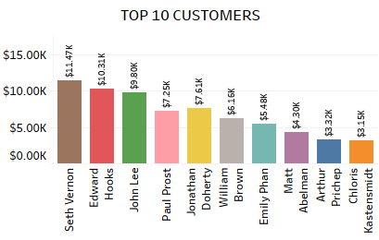

## TOP 10 CITIES (PROFIT AND SALES)

Using superstore sales dataset, we represent TOP 10 cities sorted by their profit and sales value.

The insights of this graph is that New York city has the max profit and sales value.

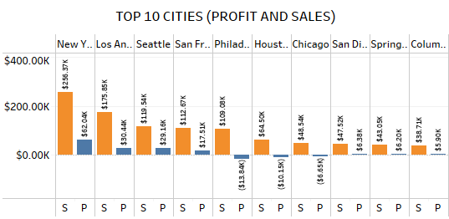

## TOP 10 PRODUCTS (PROFIT)

Using superstore sales dataset, we represent top 10 products of the company by the profit they bring for this company.

The insight of this graph is that easy-staple paper is their top product by earning highest profit of $1.10K for the company.

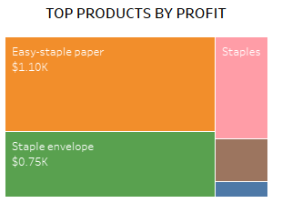

**PRODUCTS ORDER AND RETURNS**

Using super store sales dataset, we represent the top 10 products according to their orders and returns.

The insights of this graph is that product Staple envelope is the top product of this company according to the orders and returns.

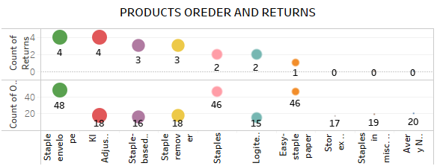

## Dashboard

Our final dashboard is designed to offer dynamic exploration of superstore sales performance, featuring an innovative category selection option for enhanced analysis. Crafted meticulously using Tableau, this dashboard serves as a gateway to a wealth of insights derived from our superstore analysis mini project.

• Category Selection Option: Experience the power of dynamic analysis with our category selection feature. Choose from a range of categories such as profit and sales of different states. Upon selection, all graphs and visualizations on the dashboard adapt to display insights specific to the chosen category.

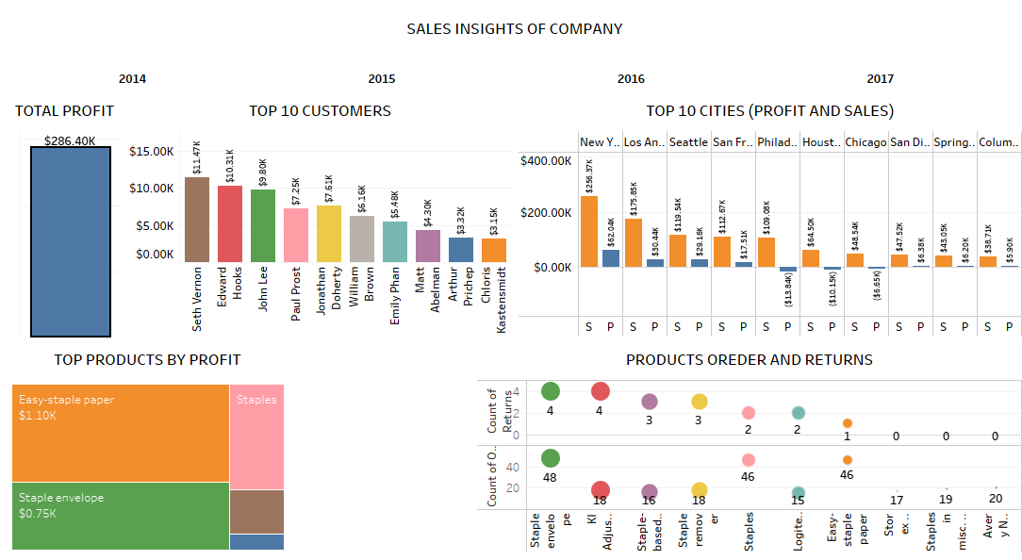

# Conclusion

The Superstore Dataset Analysis Mini Project underscores the significance of data-driven insights in informing strategic decisionmaking processes. By delving into region wise profit and sales, year wise profits, top 10 products, top 10 customers and products orders and returns can tailor their approaches to sales analysis, thereby driving sales growth and improving profitability.

# Future Directions

Future iterations of this analysis could explore additional dimensions of sales in superstore, based on above graphs we conclude about the sales of which state is more , sales and profits in which year is more and which region has profit on sales.